Questions  If you have any questions about our privacy policy or the information we hold about you, you can:  - Contact us via email  - Write to the practice manager  - Ask to speak to the practice manager or their deputy  The practice’s privacy policy is also available on our website. | Dr Malik Practice  Kent Elms health Centre ,1 Rayleigh Road  Leigh On Sea Essex SS9 5UU  01702 529333 malik.surgery @nhs net. |  | How we use your information  - DR MALIK PRACTICE
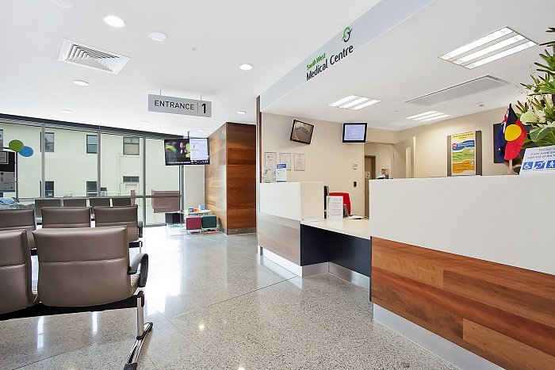  Privacy notice  Dr Malik’s Practice has a legal duty to explain how we use any personal information we collect about you as a registered patient at the practice. Staff at this practice maintain records about your health and the treatment you receive in paper and electronic format.  Information we collect  We will collect information such as personal details, including name, address, next of kin, records of appointments, telephone calls, your health records, treatment and medications, test results etc. and any other relevant information. relation to your care. | At Dr Malik’s Practice we will ensure that patients are informed about how the information we hold is processed and shared. All information will be processed lawfully and fairly, in accordance with the DPA 1998.  Using your information  Your data is collected for the purpose of providing healthcare services; however, we can disclose this information if it is required by law, if you give consent or if it is justified in the public interest.  Confidentiality  We are committed to maintaining your confidentiality and protecting the information we hold about you. We adhere to the Data Protection Act (DPA 1998), NHS Codes of Confidentiality and Security, and guidance issued by the Information Commissioner’s Office. |  | Sharing data  All health and adult social care organisations are required to share information about patients with each other, by law; this is to improve the care delivered to the patient. An additional requirement is that the patient’s NHS number is used as the unique identifier when sharing any information or data.  Opting out  Should you wish to opt out of data collection, please contact a member of staff who will be able to explain how you can opt out and prevent the sharing of your information. This is done by registering a Type 1 opt-out, preventing your information from being shared.  Changes to our policy  We regularly review our privacy policy and any updates will be published on our website and Posters will also be updated to reflect the changes.

