**Responses Overview Active**



Responses

**92**



Average Time

**01:44**



Duration

**34** Days

1. Box BoxBoxBox Overall how was your experience of our service?

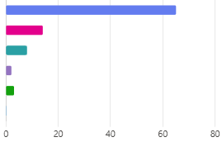

|  |  |
| --- | --- |
| Very good | 65 |
| Good | 14 |
| Neither good nor poor | 8 |
| Poor | 2 |
| Very poor | 3 |
| Don't know | 0 |

1. BoxBoxPlease can you tell us why you gave your answer?

|  |  |
| --- | --- |
|  | Latest Responses |
| 91 | "Dr explained options available." |
| "Seen quicly an hospital appnintment sorted next day" |
| Responses | "Quick reply to my message plus appointment." |
|  | *. . .* |



**11 respondents (12%) answered Best for this question.**

**Update**

**professional nurse**

**nurse was very good**

**thorough message Doctor Dr Best**

**Quick and efficient Mir**

**appointment on time reply very good**

**appointment Prompt response**

**Nurse put me at ease**

**helpful**

**service time**

**future appointments**

**appointment for that same day**